Supercharging Project, Program & Portfolio Management with Technology

**Helping you get to Demand, Capacity & Strategic Planning**

Presented by Tim Runcie, MCTS, MCP, PMP, MVP



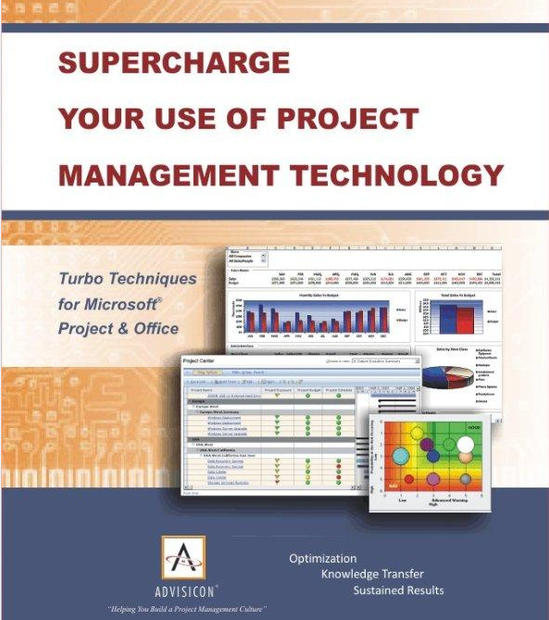

# **Benefits of PPM / Dashboard Overview**

# 

# Notes:

# **Key INgredients**

# 

# Key Ingredient Notes:

# **Full Spectrum of Methodologies**

# 

# Methodology Notes:

# **What Should Happen / Efficient Process:**

# 

# Effiecient Process Notes:

# **Ability to Promise / demand Management/ Resource Capacity / Strategic Planning:**

# 

# Capability Notes:

# **MS Product Demonstration:**

# 

# Scalability Project / Server / SharePoint Notes:

# **Lean Approach (Tools, Training, Methodology):**

# 

# Lean Approach Notes: